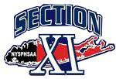

2026 Unified Bowling
Mandatory Coaches Meeting
Mark Mensch
Section XI Unified Sports Coordinator
Markmensch2@gmail.com
631-375-5241

Season Dates:
February 11, 2026 @ 6:30 PM Coaches Meeting via ZOOM
Season Starts: February 23, 2026
Teams/Players required to participate in 6 Practices for Eligibility
Rules: Score Sheets available on Section XI Website, Unified Bowling Page
NYSPHSAA Handbook Pages 142/143
Not Post Season

